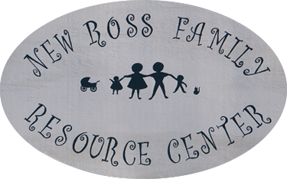
4689 HIGHWAY 12
NEW ROSS N.S.
B0J 2M0
PHONE 689-2414
FAX 689-2092
EMAIL: nrfrcnewross@hotmail.com

Application for use of New Ross Family Resource Centre Chromebook

To be completed by Applicant

Date of Application: _________________________________________________________________________

Applicant: ____________________________________________________________________________________
(Name)
Address: ______________________________________________________________________________________

Telephone (home): ____________________________ (cell): _______________________________

E-mail: ________________________________________________________________________________________

Number of estimated Chromebook users: _________________________________________________
* Renters must provide their driver’s license for NRFRC to photocopy & keep on file

To be completed by NRFRC staff

Staff renting out Chromebook: __________________________________________________________

Date of rental: _________________________ Duration of rental (max 1 month): ______________

Purpose for which the Chromebook will be used: ______________________________________
________________________________________________________________________________________________
________________________________________________________________________________________________

************************************************************************************
Applicant Signature: _______________________________________________Date: ___________________
Rental Agreement Approved by NRFRC staff:
Signature: ____________________________________ Date: _________________________________________
Chromebook # rented: ___________________________________________________________________
As a Chromebook renter, I agree to the following:

Waiver
The undersigned Organization or Individual Renter hereby assumes all risk for damage, theft, or loss which may arise while renting a New Ross Family Resource Centre Chromebook.

I have carefully read this application agreement and understand the terms and conditions of the agreement and agree to be bound by them.

I agree to:
- Provide the NRFRC with a photo of my ID (driver’s license, etc.)
- Use the NRFRC Chromebook with care and respect.
- Use the Chromebook for physical, mental, and or emotional health-related activities only, such as utilizing online mental health and or medical supports, attending virtual healthcare appointments, connect with my support group, etc.
- Return the Chromebook to the Centre on time in the exact same condition it was when rented.

Please sign below that you have read the above information and are in agreement:

Signature: ___________________________________________ Date: _______________________________

Thank you for your cooperation and support!

NRFRC staff.

************************************************************************************

