Why is play important?  Every baby is born ready to learn. In the early years of childhood development, your child’s main way of learning and developing is through play – exploring, observing and experimenting.  Play stimulates the brain and helps the child, at a very early age, engage, interact and start making sense of the world around them. Play contributes to the cognitive, physical, social, and emotional well-being of a child as well. Play also helps your child build confidence, feel loved and develop communication skills.  Play also offers an ideal opportunity for parents to engage fully with their children. |  | Playgroup  4691 Hwy 12  New Ross, NS  B0J 2Mo | Who We Are  About Us  New Ross Family Resource Centre strives to reach all members in our community, from the young to the young at heart. We are a non-profit facility responsible for bringing health and well-being programs to the residents of New Ross and surrounding areas. Our goal is to make New Ross area a comfortable, well-serviced community with many of the amenities provided in larger areas.  Contact Us  Karen Snair, B.C.Y.S.  Certified Car Seat Technician Services also available. Karen can conduct child safety seat checks, educate, support and guide parents with hands-on assistance for proper use of child safety seats and safety belts.  Phone: 902-689-2414  Email: nrfrckaren@hotmail.com  Web: www.nrfrc.ca Facebook: www.facebook.com/nrfrc  Location  4691 Hwy #12, New Ross, NS B0J 2M0  ,  , New |  |  | Play, Learn & Grow Together!  Playgroup  - Monday & Thursday 9:30-11:30am at the New Ross Family Resource Centre

What is Playgroup?  Playgroup is a free service run by our Early Child & Parent Educator, Karen Snair, and YOU! -- the parent/grandparent/guardian.  You join your child in our  classroom, full of developmentally appropriate toys and activities for children, aged birth to school age, to freely explore and engage in.  We provide tea and coffee for the parents and a healthy snack for the children. Throughout the morning an art activity, and Circle time (songs, finger plays and stories) will be offered. We encourage parents to join their children in their play time and during group activities.  If you have any parenting related questions, or concerns we will try our best to answer them, offer you suggestions, lend you resources or help guide you in the right direction. |  |  | Why do children go to Playgroup?  Playgroup aged children are going through rapid brain and skill development. Babies are offered play experiences to stimulate their senses. Toddlers continue to build on these play experiences to practice using their hands and their emerging language skills. Preschool children continue to learn as they play and practice social skills and fine and gross motor skills.  “I bring them (my children) so they can socialize with other kids and learn and have fun at the same time...and I get to socialize with other parents!”  Is Playgroup just for children?  No. At playgroup you get to meet other adults who are going through similar experiences, ease the isolation that can happen when caring for young children, and find out about the local community, health & safety practices, development of your child, nutrition guidelines, and other topics that are of interest to you and your family. You also grow your own relationship with your child as you experience new things alongside them, in a safe environment. |  |  | 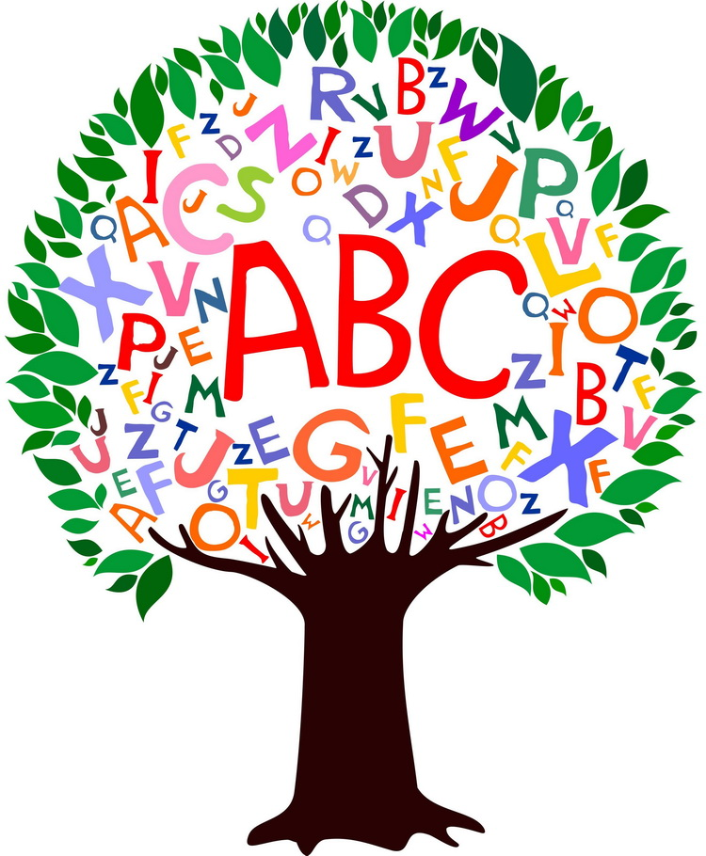  At Playgroup Children Can:  - make new friends  - have new experiences  - gain self confidence  - develop physically, socially, emotionally, and intellectually  - develop skills of cooperation  - develop non-verbal and verbal communication skills

