Health & Fitness ALZHEIMER SUPPORT GROUP Join Diane & Susan on the 2nd Wednesday of each month from 1:00 -3:00pm.  NURSE PRACTITIONER  Nancy MacDonald will be at the Centre once a month. If you are a patient of hers or Dr. Cox in Chester, you can call 902-275-5268 to book and appointment.  BLOOD COLLECTION SERVICE Blood collection is every second Wednesday from 8:30 – 10:00am here at the Centre, with home visits available with Coleen Hull by appointment, call 902-624-0406.  TOPS  “Take Off Pounds Sensibly” is a weight loss support group that meets every Monday at 6:00pm here, at the Centre.  ADULT FITNESS CLASSES Classes will be available throughout the year. Contact the Centre .  NEW ROSS FITNESS CENTRE We have a full range of fitness equipment, and are open 7 days a week, 24 hours a day. Call for more details regarding membership.  YOGA  Every Friday from 9:00-10:00am, please contact the Municipality of Chester for more details at 902-275-3490.  THE FLYER  We distribute our own newspaper to residents of New Ross, it includes activities in and around New Ross and is produced at the Centre. It can also be found online. |  |  | HOME SUPPORT EXERCISE PROGRAM (HSEP)  The HSEP was developed for older adults living at home. The exercises will help improve your endurance, balance, strength and flexibility.  NUTRITION SESSIONS  A variety of cooking sessions will be offered throughout the year with Leanne, our Dietitian and Nutritionist, contact her for more info.  NEW ROSS COMMUNITY FOOD PROJECT  This is led by a group of community members and partners working to build a more sustainable food system in New Ross. Contact Leanne if you are interested in getting involved or for information on food project programs.  We also offer room rentals for birthday parties, showers, community meetings, etc. Feel free to call us for more  information.  Contact Us  Phone: 902-689-2414 Fax: 902-689-2092  Diane Email: nrfrc@sympatico.ca  Karen Email: nrfrckaren@hotmail.com  Leanne Email: nrfrcleanne@gmail.com  Janice Email: corneliusjl13@gmail.com Web: www.nrfrc.ca Facebook: www.facebook.com/nrfrc  Community Website: www.newross.ca |  |  | 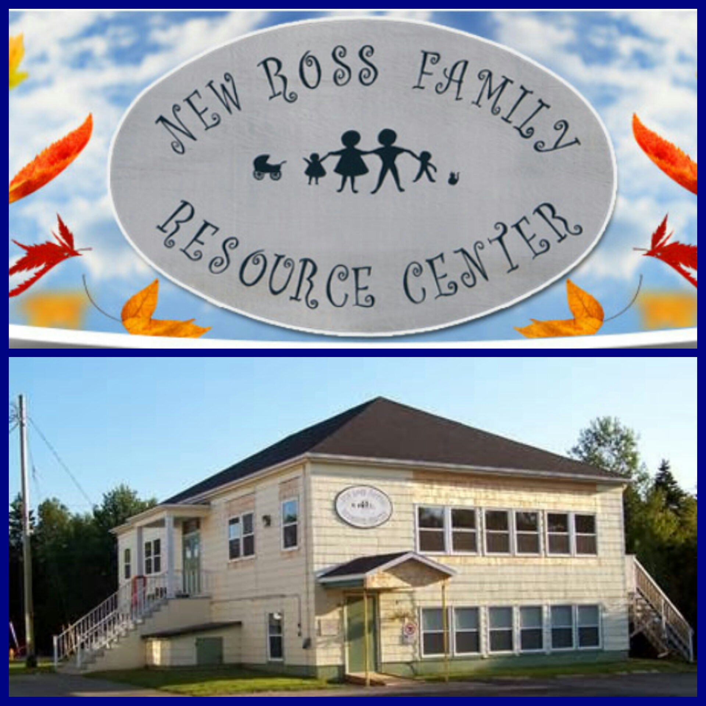  New ross family resource centre  - 4691 Highway 12, P.O Box 106, New Ross, NS B0J 2M0 Phone: (902)689-2414

Mission Statement  We are a non-profit facility responsible for offering programs that bring health and well-being to New Ross and the surrounding communities. Our goal is to make New Ross area a comfortable, well-served community with many of the amenities provided in larger areas.  Babies, Children & School Age  PRENATAL PROGRAM  A great way to learn more about pregnancy, childbirth, meeting other mom’s, and having a new baby. One-on-one or small groups. Contact Leanne for more information on this free program.  BREASTFEEDING SUPPORT This free, peer support program aims to support mothers, one-on-one with the learning experience of breastfeeding. Contact Leanne for more information.  PLAYGROUP  This is a free program offered to children birth to 5 years. Activities include crafts, songs, games, story time, and a healthy snack. Offered on Mondays and Thursdays throughout the school year from 9:30-11:30am, and Mondays only during the summer.  CAR SEAT SAFETY  If you have questions regarding your child’s car seat, Karen is a qualified Child Restraints Systems Technician and can educate, support and guide you for proper use of child safety seats and safety belts. |  |  | NOBODY’S PERFECT  Open to every parent/guardian with children from birth to age 5. Come reflect, brainstorm and work together to solve parenting concerns and questions. Contact Diane or Karen.  PRESCHOOL  This is a licensed program for children from 2.5 – 5 years, one morning a week. It is moved into the New Ross Consolidated School, contact Karen for more information.  TUMBLEBUGS  For children ages 3.5 – 5 years old, it is an intro to basic movement and modified gymnastics. It will be offered once yearly.  AFTER SCHOOL PROGRAM  Join Janice every Monday, Wednesday and Friday throughout the school year for fun, activities, and a healthy snack.  NEW ROSS AFTER SCHOOL  We partner with NRCS to provide a free afterschool activity based program one afternoon a week. Activities may include crafts, cooking, archery, music, etc.  FAMILY GYM NIGHT  In partnership with NRCS, this program is offered Wednesday evenings. Time frames have been established according to the different age groups.  PLUG INTO MUSIC  Local musician, Jamie Junger, will help youth in developing an appreciation of music, performing and recording tips from the pros, songwriting, and much more! 10 week Spring Program.  “Don’t be shy! Show them how fabulous you are! This is a great spot for a glowing testimonial.”  Get the exact results you want  To easily customize the look of this brochure, on the Design tab of the ribbon, check out the Themes, Colors, and Fonts galleries.  Have company-branded colors or fonts?  No problem! The Themes, Colors, and Fonts galleries give you the option to add your own. |  |  | DANCE CLASSES  In partnership with Dance ConXion we offer kids dance including creative movement, hip hop and jazz classes on Friday afternoons. Please call to confirm day/time as this may change due to teachers’ availability.  PLUG INTO MUSIC EXPANED Free program with Jamie Junger providing an opportunity to explore the many musical instruments we have on Wednesdays from 6:30-7:30pm at the NRCS.  PIANO LESSONS  Teacher Margo Eisner offers lessons every Wednesday at the Centre. Call her at 902-277-2851 for more information.  RAINBOWS  ‘Rainbows’ fosters emotional healing among children, grieving from a loss or life-altering crisis. Contact Diane for more information.  GIRL TALK  We provide a safe, group setting for girls aged 9 – 12 to talk about things that are important to them. Held annually, contact the Centre for more information.  SUMMER PROGRAMS  Our Summer Programs try to meet the ever changing needs of the community and can include: Day Camps, Arts n’ Crafts, Little Tykes (a transition to school program), Summer Soccer, Swimming Classes (Red Cross), and Tennis Lessons. Such programs are based on instructor availability.

